Miami Herald, October 2, 2015

American justice: A U.S. lawyer in Colombia’s peace process
Doug Cassel helped nail down a justice system for Colombia’s peace process
The legal innovation removes one of the last obstacles to ending 50-year civil conflict
A system that prizes truth over prison has its skeptics
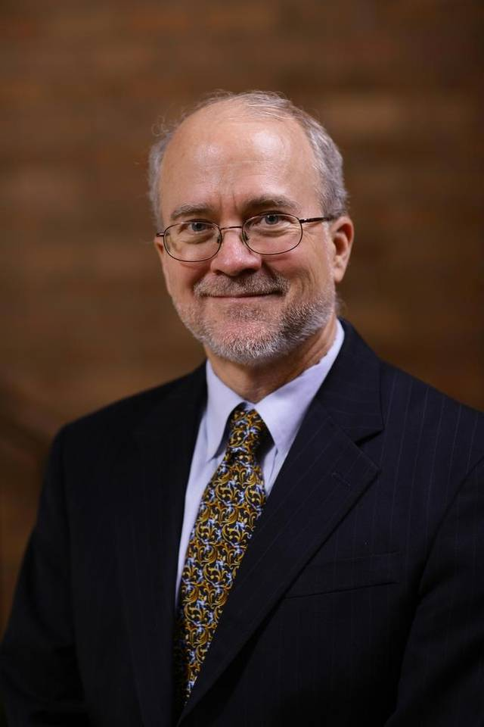
Doug Cassel Matt Cashore

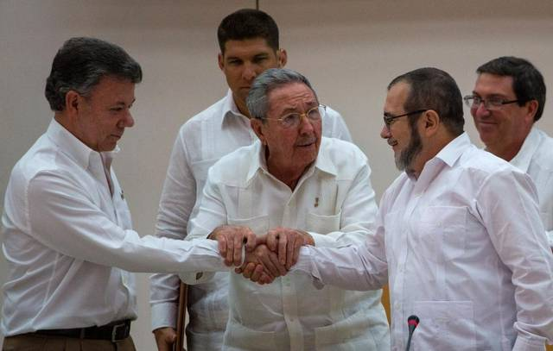
Cuba's President Raul Castro, center, encourages Colombian President Juan Manuel Santos, left, and the commander of the Revolutionary Armed Forces of Colombia or FARC, Timoleon ‘Timochenko’ Jimenez, to shake hands in Havana on Sept. 23. Desmond Boylan AP

BY JIM WYSS
jwyss@miamiherald.com

BOGOTA, Colombia
Doug Cassel, a human-rights lawyer, was in his office at the University of Notre Dame when his phone rang. It was May 14, and on the other end was Colombian President Juan Manuel Santos.
For more than two years, Colombia had been trying to hammer out a peace deal with the country’s largest guerrilla group in hopes of ending the hemisphere’s oldest and bloodiest civil conflict, and things were not going well.
In April, the Revolutionary Armed Forces of Colombia, or FARC, broke a tenuous ceasefire and ambushed an army encampment, killing 11. In May the government retaliated, bombing a guerrilla outpost, leaving more than two dozen dead. A week later, the guerrillas officially scrapped their unilateral ceasefire.
As battlefield casualties mounted, the peace negotiations, taking place in Havana, also seemed to hit a wall. Rebel leaders were opposed to signing a deal that would send them to prison, but the government needed punishments harsh enough to satisfy a skeptical public and the millions of victims of the half-century conflict.
“The whole peace process almost broke down,” Cassel told the Miami Herald. “The ceasefire had been lifted and people were being killed on both sides.”
It was amid this scenario that he got the call. Recognizing the impasse, negotiators in Havana convened a commission with three experts from each side. The group’s orders were to find a way to deliver justice without sabotaging the peace talks. And Santos wanted Cassel, a 67-year-old lawyer and scholar, on the government’s team.
The solution they came up with, after seven weeks of intense negotiations, was unveiled on Sept. 23 and it has been hailed from the Vatican to Washington as a major breakthrough.

Six months from peace?
Acknowledging that the issue of justice, the largest obstacle to a definitive deal, had been cleared, Santos and his guerrilla counterpart, FARC Commander Rodrigo “Timochenko” Londoño, vowed to wrap up the rest of the talks by March 23. And the guerrillas pledged to lay down their weapons within 60 days of signing an accord.
On Wednesday, Londoño went further, writing on Twitter that he had ordered troops to cease military training and begin “political and cultural” courses as they prepare for civilian life.
Santos used the world’s most public stage, the United Nations General Assembly, to share the news.
“I’m here to tell the world that in Colombia, within six months, the bells will ring announcing the hour of peace,” he said.
If his relief was palpable, there was good reason: the stakes were high.
We did not have misión imposible we had misión casi imposible.
Doug Cassel, human rights lawyer.
“We did not have misión imposible, we had misión casi imposible“ — an almost impossible mission, Cassel said. “I never entirely gave up, but there were certainly some tough moments.”
There were two major sticking points to the deal, he said. The first was whether war crimes and other atrocities would be tried in the courts or handled in an extrajudicial manner. The other issue was prison. The FARC demanded a system focused on reparations without restrictions on their liberty, Cassel said.

Tailor-made justice
What the team came up with is innovative. Under the deal, a special tribunal will hear charges against both the guerrillas and the military. Those accused of serious crimes in the context of the conflict — including rape, torture, kidnapping and child recruitment — and who tell the truth and cooperate, will face five to eight years in confinement other than prison. Those who don’t tell the full truth will do the time in a prison, and those who maintain their innocence but are found guilty can face up to 20 years behind bars.
Critics, including human-rights groups and former president Álvaro Uribe, have balked that guerrilla commanders with blood on their hands won’t face prison time under the regime.
And while that’s true, Cassel said the system needs to be seen in its entirety: It’s a mix of reparations, non-repetition, truth-telling and restrictions on liberty.
“You can’t pluck one item out of the menu and look at it in isolation,” he said. And the fact is, prison terms for the FARC would have been a show-stopper; in peace treaties, a deal is only as punitive as both sides will accept.
“Go find someone to agree with you to accept prison time,” Cassel said, “and I will applaud you.”
Santos echoed that thought in New York on Wednesday as he explained why FARC commanders would not face extradition to the United States. “Nobody is going to lay down their weapons to spend 40 years in a U.S. jail,” he said.

Truth matters
María Eugenia Cruz is part of a support group for women who were sexually assaulted amid the conflict. She said there’s no amount of punishment that will heal wounds. Instead, most people yearn for closure.
“Beyond thinking about things like life sentences, as long as there’s the commitment to tell the truth and non-repetition, then justice is being served,” she said.
There’s still much that remains unknown about the deal, including what “confinement” might actually look like.
When pressed on the issue last week, Peace Commissioner Sergio Jaramillo said those convicted under the special tribunal will be relegated “to specific locations and be under guard.” But they will also need to leave those areas to provide reparations to their victims, which might include everything from helping clear minefields to asking communities for forgiveness.
“The system has to be sufficiently flexible,” Jaramillo said.
There is also the issue of amnesty. Minor “political” crimes and those inherent in the act of armed rebellion, like the illegal carrying of arms, will be pardoned under the system.
But it will be up to Colombia’s congress to decide how far amnesty reaches. And that has raised the question of whether FARC members accused of drug trafficking will see those charges disappear. The guerrillas maintain that they’re not directly involved in the drug trade, but rather that they tax crops to finance their revolution, so it should be seen as a political offense.
There is nothing in international law that prohibits amnesty for drug traffickers, Cassel said, so the issue “will have to be part of the negotiations in the Colombian congress.”

Enemy of the state?
Cassel was a natural choice for the job. He was a legal adviser to the UN Truth Commission in El Salvador in the 1990s, and has consulted with countries around the world on peace processes. He also brought something else to the table: He has the ear of Bernard Aronson, the U.S. Special Envoy to the Colombian peace process.
Cassel became a prominent figure here in the late1990s when he sued Colombia in international court over the killing of 17 people in the town of Santo Domingo. The government initially blamed a guerrilla truck bomb, but villagers said they’d been attacked by army helicopters. Forensic tests showed the villagers were right and Cassel’s team won. He also won critics in high places. Ex-President Uribe has called him “an enemy of the armed forces and the Colombian state.”
“I’m a professional human-rights lawyer and I work in the field of human rights, not politics,” Cassel said. “If they’re worried that I’m a FARC leftist they should see cases I’ve filed against Venezuela, Ecuador and Cuba.”
Also on the government’s side were former judge Manuel José Cepeda and university dean Juan Carlos Henao. Representing the guerrillas were Spanish lawyer Enrique Santiago, politician Álvaro Leyva and human-rights defender Diego Martínez.
Although Colombia can celebrate getting close to a final deal, peace is not a given. The tricky process of guerrilla disarmament and demobilization needs to be hammered out. And the FARC need assurances their safety will be guaranteed as they transition into civilian life.
If a deal is reached, however, some of the credit will belong to the team that tried to find the balance between justice and peace.
“For me as an American,” Cassel said, “it has been a tremendous honor to try to accompany the Colombian people in an effort to finally put this tragedy to an end.”
Read more here: http://www.miamiherald.com/news/nation-world/world/americas/colombia/article37252302.html#storylink=cpy

